Effect of porosity on the ferroelectric and piezoelectric properties of (Ba0.85Ca0.15)(Zr0.1Ti0.9)O3 piezoelectric ceramics

Emily W. Yapa, Julia Glauma, [1], Jette Oddershedeb, [2], John E. Danielsa

a School of Materials Science and Engineering, UNSW Australia, NSW 2052, Australia

b Department of Physics, Technical University of Denmark, 2800 Kongens Lyngby, Denmark

Corresponding author: j.daniels@unsw.edu.au

**Abstract (100 words)**

The ferroelectric and piezoelectric properties of (Ba0.85Ca0.15)(Zr0.1Ti0.9)O3 (BCZT) ceramics were measured as a function of porosity, porous BCZT ceramics were fabricated using the sacrificial fugitive technique. Two different pore morphologies were induced by adding polymeric microspheres and fibres as the pore-forming agents. Increasing porosity led to decreasing ferroelectric and piezoelectric properties due to a reduction of polarisable BCZT ceramic available. With the benefit of being a lead-free piezoelectric material, porous BCZT ceramics may be considered for acoustic impedance matching in actuator and sensor applications, and also as a functional component in biomedical applications.

**Keywords :** Porous material, piezoelectric ceramics, electroceramics, three-dimensional tomography, finite element analysis

Functional piezoelectric materials have typically been produced as dense ceramics in order to achieve a high piezoelectric response and reliable performance. Porosity in these materials is generally considered a defect, reducing the quality of piezoelectric response and mechanical stability properties. However, porous piezoelectric ceramics have potential benefits in given applications. For example, porosity can be used to improve the acoustic impedance matching between a ceramic and measurement media in ultrasonic applications such as ultrasonic medical imaging and underwater sonar systems [1-4]. Additionally, porous ceramics might have value for the incorporation of functional devices into biological systems, where cell infiltration may be of benefit [5, 6]; as has been proposed for potential bone replacement materials, where the piezoelectric charge generated under stress can be utilised to encourage cellular growth.

The drawback of porous electroceramics, however, is their intrinsic defects of pores make them susceptible to dielectric breakdown and mechanical failure [7-9]. The air-filled pores have a lower dielectric breakdown strength and permittivity, which significantly increases the probability for partial discharge within the pore [10]. When the electric field is applied, electrical charge accumulates within the voids causing arcing that ultimately results in mechanical failure [11]. This is particularly problematic in piezoelectric ceramics as they must undergo an electrical poling process at high DC field to activate their piezoelectric properties.

The benchmark for practical piezoelectric properties in electroceramic materials is set by the market leading lead zirconate titanate (PZT), which can have a piezoelectric coefficient, d33, of up to 600 pC/N [12]. While most lead-free piezoelectric ceramics have been found to exhibit a piezoelectric coefficient, d33, of typically ~100 to ~300 pC/N [12, 13], BCZT ceramics have reported d33 values of up to 620 pC/N [14]. Additionally, BCZT ceramics contain no significantly toxic elements and therefore have the potential to be used in biological environments. While information is available on the composition dependence of the ferroelectric and piezoelectric properties of BCZT, it is unknown if these materials can be produced with porosity and retain their ferroelectric and piezoelectric properties.

Here, porous BCZT materials were fabricated by mixing sacrificial fugitives as pore-forming agents with ceramic powders that were then compressed together prior to sintering. Polyethylene (PE) microspheres and fibres were added to the ceramic powders to obtain two distinct pore morphologies. It was shown that in these compositions, desirable ferroelectric and piezoelectric properties were retained even when increasing the volume fraction of pore-forming agents to 50%.

The ceramic powder of BCZT was prepared by the conventional solid-state reaction process using the raw materials viz., barium carbonate (99%, Ajax Finechem UNIVAR® Analytical Reagent), calcium carbonate (99%, Ajax Finechem UNIVAR® Analytical Reagent), zirconium dioxide (99%, Sigma-Aldrich) and titanium dioxide (99.8%, Sigma-Aldrich). The powders were ball-milled for 72 h with zirconia balls and 95% pure ethanol. After drying at 95 $°$ C for 24 h, the ground powder was calcined in a zirconia crucible at 1300 $°$ C for 2 h with a heating and cooling rate of 5 $°$ C/min. The powders were ball-milled and calcined again before being sieved through a mesh size of 75 $μm$ (ASTM E-11 #212).

The microspheres (Ø 38 – 75 µm) and fibres (Ø 10 µm) were used to create pores within the microstructure by pyrolysis during the fabrication process. Volume fractions of 10 vol.% (10MS) and 50 vol.% (50MS) microspheres were mixed with the BCZT powders by hand using a micro spatula and mortar. A sample containing a combination of 30 vol.% microspheres and 10 vol.% fibres (30MS/10F) was produced in a similar manner, with an additional step to separate fibre entanglements and ensure homogeneous mixing. The powder mixtures were compacted into cylindrical pellets in a Ø 10 mm die using a uniaxial press with a pressure of 40 MPa for 1 min. The pressed powders were heated to 500 $°$ C for 1 h to allow the pore-forming agents to burn out before sintering of the ceramic at 1450 $°$ C for 3 h at heating and cooling rates of 5 $°$ C/min. The burn-out temperature of the pore-forming agents was confirmed by thermogravimetric analysis of the pore-forming agents mixed with BCZT ceramic powders. Samples containing no pore-forming agents were also prepared, which will be further referred to as 0MS. The phase purity of the ceramics was confirmed by XRD measurements on a PANalytical Empyrean XRD system.

The surfaces of the pellets were polished using SiC polishing papers from a starting grit size of 320 to 4000. The pellets were then further prepared for the microstructural analysis and piezoelectric characterisation by cutting each sample into 1 mm × 1 mm × 5 mm pillars. X-ray microtomography (Imaging Industry Portal, Technical University of Denmark, Lyngby, Denmark) was carried out using a Nikon XT H 225 to obtain a 3D density distribution of the samples with a spatial resolution of 3-5 m. The Simpleware ScanIP software (Synopsys, Mountain View, USA) was used on each 3D density distribution for image processing, segmentation of the ceramic and pore regions, and model reconstruction. The porosity of each sample was calculated using the Simpleware ScanIP software from the tomographic data, which is of a section of each sample pillar.

For piezoelectric measurements, two parallel surfaces of each pillar were sputter-coated with gold. The characterisation of the piezoelectric properties was carried out using an aixACCT TF Analyzer 2000 test setup (aixACCT Systems GmbH, Aachen, Germany). The sample was placed in a silicone oil bath at room temperature. Polarisation and strain measurements were measured using a triangular waveform with electric field amplitude of $±$ 1 kV/mm at a frequency of 1 Hz.

A 3D finite element analysis of the electric field distributions was carried out using COMSOL® Multiphysics to understand the behaviour of porous BCZT and its ferroelectric and piezoelectric properties. A surface mesh model of the tomographic data of 50MS was generated in the Simpleware ScanIP software and imported into the COMSOL® Multiphysics AC/DC module. The model was simulated under the conditions of a static electric field between two parallel surfaces. The faces parallel to the direction of the applied electric potential were maintained at zero charge. The pores were assumed to be filled with air and had a zero surface charge density.

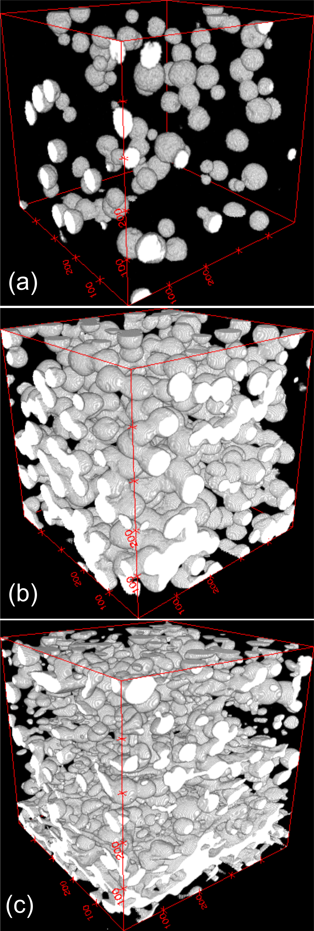

Figure Pore structure of the samples 10MS (a), 50MS (b) and 30MS/10F (c) obtained by X-ray microtomography. The box volume in each image is 500 x 500 x 500 µm3.

**Table 1 Porosity of samples.**

|  |  |  |
| --- | --- | --- |
| Sample | Vol.% of Pore-Forming Agents | Measured Porosity (%) |
| 10MS | 10 | 3.90 ± 0.5 |
| 50MS | 50 | 25.4 ± 2.9 |
| 30MS/10F | 40 | 20.8 ± 3.9 |

The X-ray microtomography reconstructions (Figure 1) and the associated porosity measurements (Table 1) show that a higher volume of pore forming agents created more porosity in the sample, as expected. However, the measured porosity was lower than the corresponding volume of pore forming agents. This occurred during the sintering process of the ceramics where shrinkage occurs after the burn out of pore-forming agents, resulting in a reduction of the pore volume. From inspection, 10MS contained more dispersed and isolated spherical pores than 50MS. The pores in 30MS/10F were more elongated and oriented perpendicular to the pressing direction of the BCZT ceramic powders. The pore structure in 30MS/10F also appears more connected as fibre-shaped pores with a large aspect ratio are able to provide better connectivity between the dispersed spherical pores, as explained by Zhang et al. [4].

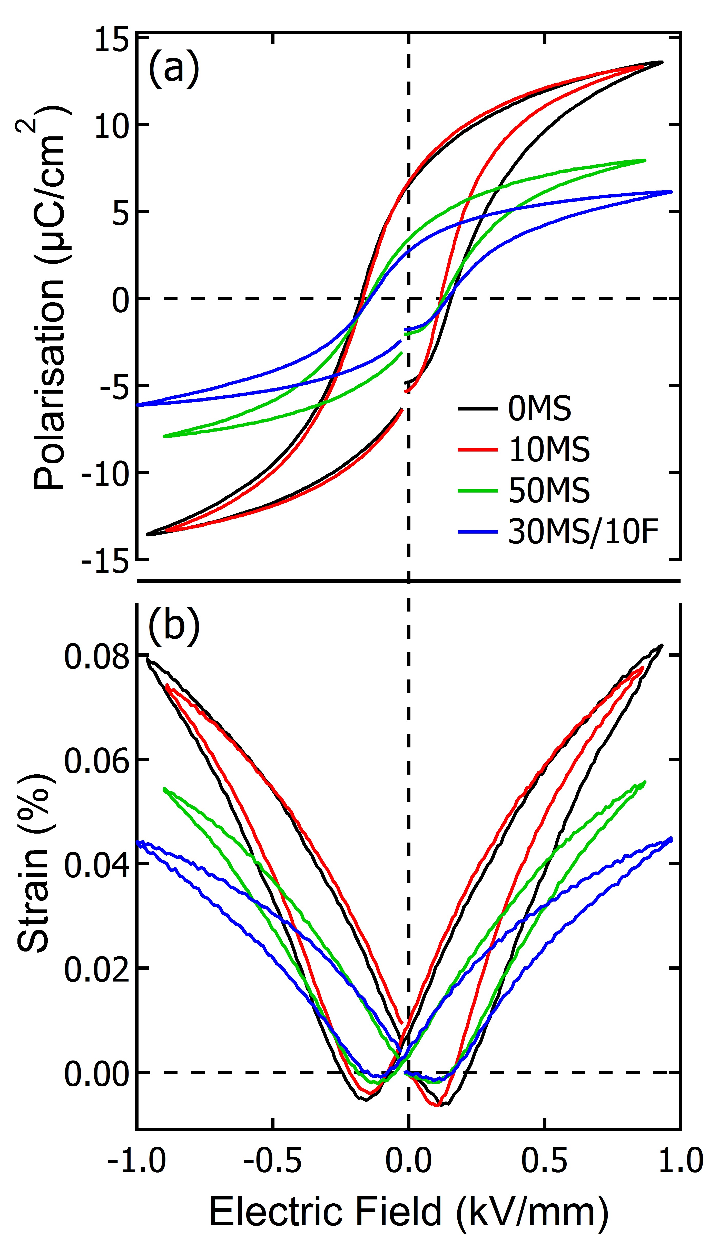

Figure Polarisation hysteresis loops (a), and strain hysteresis loops (b), of BCZT with four different mixtures of pore-forming agents.

Despite the presence of 20.8% maximum porosity, Figure 2 shows the existence of ferroelectric and piezoelectric properties in all the samples. From 0MS to 50MS, the remanent polarisation, Pr, dropped by ~50% from 6.27 to 3.01 µC/cm2. Similarly, the maximum strain, Smax, dropped by ~32% from the dense 0MS to the porous 50MS ceramic. However, for all levels of porosity, the coercive field, Ec, remained stable at 0.13 - 0.14 kV/mm. The decrease in remanent polarisation is primarily due to the reduced amount of bulk ceramic available, *i.e.* the material is now a composite between ferroelectric ceramic and air. Furthermore, introducing pores into dense ceramic will cause stress concentrations near the pores during electromechanical actuation. This could affect the piezoelectric properties of the bulk ceramic due to constrained or enhanced domain wall motion in these regions. [15, 16]. The stressed regions may also increase depolarising factors, as described by Okazaki [17], resulting in a decrease in the remanent polarisation. This is consistent with observations reported by others, where porous piezoelectric ceramics had lower piezoelectric properties and relative permittivities compared to their dense counterparts [18-21].

The difference in the ferroelectric and piezoelectric properties of 50MS and 30MS/10F is mainly related to the two samples’ difference in the shape of the pores. Contrary to the trend of increasing porosity resulting in decreasing ferroelectric and piezoelectric properties, 30MS/10F had the lowest polarisation and strain of the prepared samples. After poling, 30MS/10F produced a Pr of 2.77 µC/cm2 and a Smax of 0.0443%, which were 55.8% and 45.9% lower than 0MS, respectively. The cause for this difference can be understood from the result of the finite element analysis.

In a dense ceramic, the electric field within the material is inhomogeneous due to the dielectric anisotropy of the crystalline structure. This effect is greatly amplified in porous ceramics where the material and pores have drastically different dielectric permittivity. Figure 3 shows cutaway regions of the MS50 sample where the colour scale represents the simulated electric field magnitude and the vectors the principal direction of the electric field at that point. The large contrast in permittivity between the air-filled pores and the BCZT ceramic forces the electric field to travel around the pores, resulting in areas of low and high electric field intensities around the pores. This would indicate that the porous BCZT ceramic experiencing regions of low field intensity may have incomplete poling compared to regions of high field intensity. Since 30MS/10F contains more elongated pores perpendicular to the poling direction, this sample is likely to have more areas of low field intensity. Zeng et al. [10, 16] noticed a similar trend and used the regional discharge of oval theory to explain that irregular-shaped pores will experience greater concentrated stress and electric field intensities at the tips of the pores. Thus, the bulk ferroelectric and piezoelectric properties of porous BCZT ceramics with irregular pores will be lower compared to the porous BCZT ceramics with spherical pores.

As mentioned earlier, the probability of a dielectric breakdown is likely as free charges and surface charges can accumulate along the pore surfaces, enhancing the local electric field and potentially leading to a partial discharge. In the materials tested here, dielectric breakdown did not occur during the poling, suggesting extensive partial discharge did not occur within the pores. These discharge events may be shielded from occurring due to mobile charges on the pore surfaces that are able to redistribute analogous to a hollow conductor in an electric field. This is a complex process that will depend on the electronic state of the internal pore surfaces, which is currently unknown. The fact that some electro-ceramics suffer rapid degradation in properties with increasing porosity, while others, like in this study, show retention of properties, suggests that this pore surface state likely varies significantly between material types. The ideal case would be when the properties of the inner surface of the pores are such that the apparent relative permittivity of the pore closely matches that of the bulk ceramic. Here, no field enhancements around the pore structures would be expected, minimising the likelihood of mechanical failure due to electric-field-induced stress distributions.

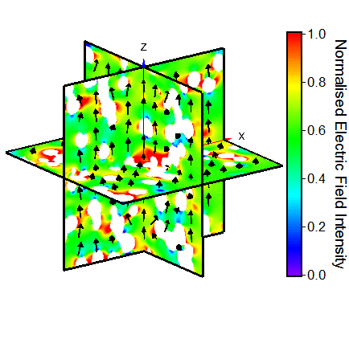

Figure Simulated electric field distribution within MS50, assuming the pores are filled with air and have zero charge on the pore surfaces. A static electric potential was applied on two parallel faces at + and –z. The resultant field intensity is shown where the colour scale reveals the magnitude, and the vectors show the direction of field maximum.

Pore-forming agents of PE microspheres and UHMWPE fibres were selected to give a variety of controlled pore shapes. X-ray microtomography revealed significantly different pore morphologies and interconnectivities between the samples that only contained microspheres compared to the sample that contained both microspheres and fibres. An increasing porosity with up to 50 vol.% of pore-forming agents resulted in decreasing ferroelectric and piezoelectric properties. The cause for this reduction is predominantly due to the reduced volume of ceramic available to be poled. Although there was a possibility of a dielectric breakdown with the application of a high electric field, all of the porous samples were able to reach their poled states. While this behaviour has not been well understood, the absence of dielectric breakdown opens the opportunity to utilise BCZT, which is also a lead-free piezoelectric ceramic, as an alternative in a variety of applications where porosity is necessary, such as to improve the performance of acoustic impedance matching and functional components in biomedical settings.

**Acknowledgements**

This project was supported in part by Australian Research Council Discovery projects DP120103968, DE120102644 and DP130100415. Jette Oddershede acknowledges support from the Danish Independent Research Council | Technology and Production Sciences case No. 12-127449. We thank the Imaging Industry Portal at the Technical University of Denmark for access to the tomography instrument. This work was performed in part of the NSW node of the Australian National Fabrication Facility, a company established under the National Collaborative Research Infrastructure Strategy to provide nano and micro-fabrication facilities for Australia’s researchers. We thank Tracie Barber for time on the Simpleware ScanIP software.

**References**

[1] C. Galassi, Journal of the European Ceramic Society 26(14) (2006) 2951-2958.

[2] E. Mercadelli, A. Sanson, C. Galassi, Piezoelectric ceramics (2010) 111-12.

[3] T. Zeng, X. Dong, S. Chen, H. Yang, Ceramics International 33(3) (2007) 395-399.

[4] H.L. Zhang, J.-F. Li, B.-P. Zhang, Acta Materialia 55(1) (2007) 171-181.

[5] F.R. Baxter, C.R. Bowen, I.G. Turner, A.C.E. Dent, Ann Biomed Eng 38(6) (2010) 2079-2092.

[6] A.H. Rajabi, M. Jaffe, T.L. Arinzeh, Acta Biomaterialia 24 (2015) 12-23.

[7] R. Gerson, T.C. Marshall, Journal of Applied Physics 30(11) (1959) 1650-1653.

[8] B.-C. Shin, H.-G. Kim, Ferroelectrics 89(1) (1989) 81-86.

[9] A.J. Moulson, J.M. Herbert, Electroceramics: Materials, Properties, Applications Chapman and Hall1990, pp. 243 - 335.

[10] T. Zeng, Q.W. Lou, Y. Bai, X.L. Dong, Y.L. Wang, Ferroelectrics 478(1) (2015) 118-126.

[11] B.-C. Shin, H.-G. Kim, Ferroelectrics 77(1) (1988) 161-166.

[12] T.R. Shrout, S.J. Zhang, Journal of Electroceramics 19(1) (2007) 113-126.

[13] Y. Saito, H. Takao, T. Tani, T. Nonoyama, K. Takatori, T. Homma, T. Nagaya, M. Nakamura, Nature 432(7013) (2004) 84-87.

[14] W. Liu, X. Ren, Physical Review Letters 103(25) (2009).

[15] K. Okazaki, K. Nagata, Journal of the American Ceramic Society 56(2) (1973) 82-86.

[16] T. Zeng, X. Dong, C. Mao, Z. Zhou, H. Yang, Journal of the European Ceramic Society 27(4) (2007) 2025-2029.

[17] K. Okazaki, Ferroelectrics 35(1) (1981) 173-178.

[18] Z. He, J. Ma, R. Zhang, Ceramics International 30(7) (2004) 1353-1356.

[19] R. Stanculescu, C.E. Ciomaga, L. Padurariu, P. Galizia, N. Horchidan, C. Capiani, C. Galassi, L. Mitoseriu, Journal of Alloys and Compounds 643 (2015) 79-87.

[20] A. Yang, C.-A. Wang, R. Guo, Y. Huang, Journal of the American Ceramic Society 93(7) (2010) 1984-1990.

[21] Y. Zhang, M. Xie, J. Roscow, Y. Bao, K. Zhou, D. Zhang, C.R. Bowen, Journal of Materials Chemistry A 5(14) (2017) 6569-6580.

1. Present Address: Department of Materials Science and Engineering, Norwegian University of Science and Technology

   (NTNU), 7491 Trondheim, Norway
2. Present Address: Xnovo Technology ApS, Tehilgaards Alle 9, 1th. 4600 Køge